**Experiment Procedure Documentation**

**Introduction**

This document captures the instructions to run the javascript simulation.

**Instructions**

1. To run the experiment, simply run the index.html file by clicking on it and the experiment will open in the browser.

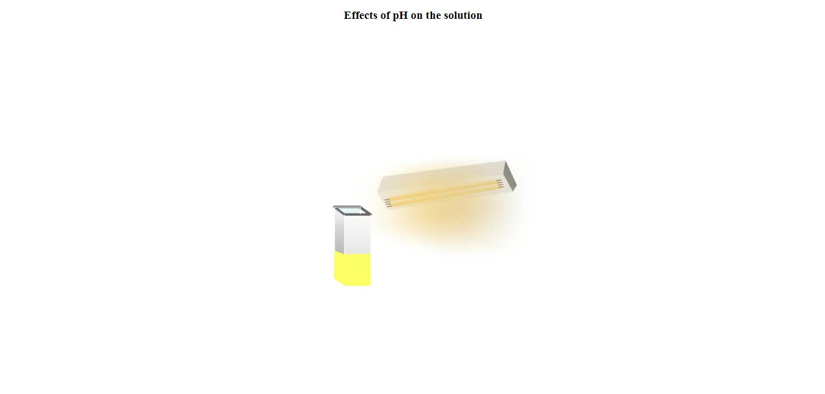

1. First, the experiment will automatically run a part of the simulation like showing the clock and preparing the experiment for a user to use, after that you need to click on the pippet for running the experiment till next click frame.

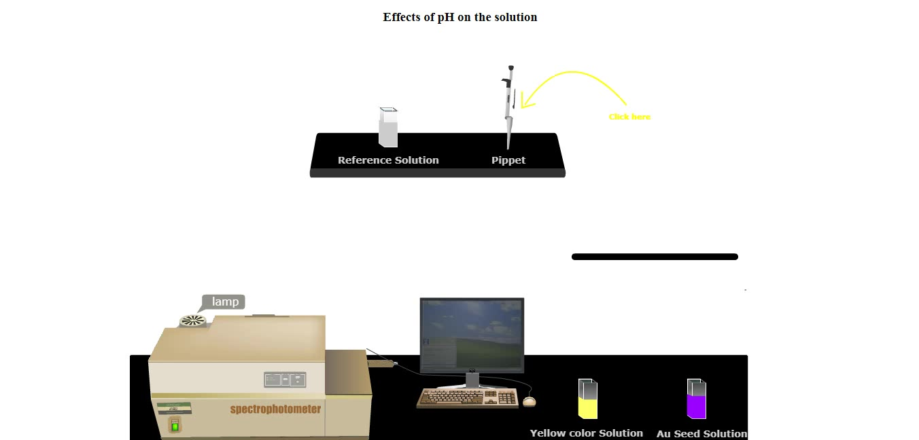

1. Similarly, click on instruments where pointer points in each frame to run the simulation

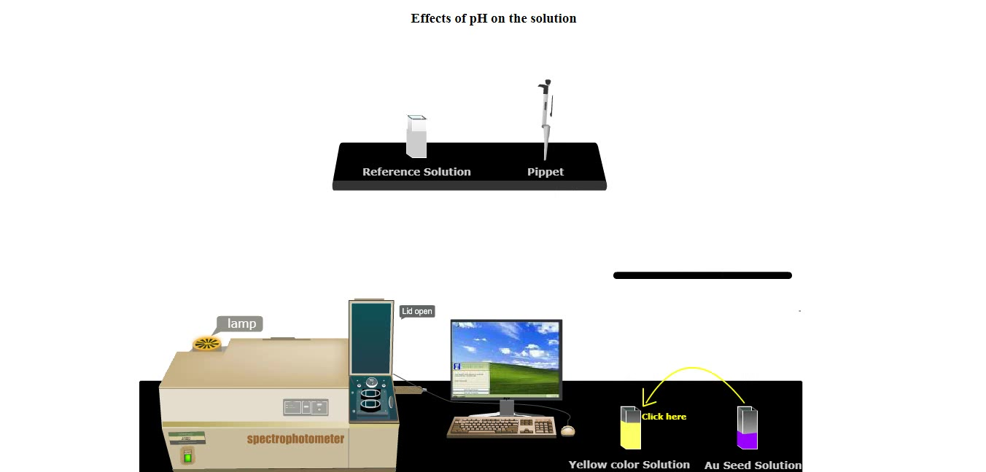

1. After some more clicking, you will reach the graph running window, where you need to click on the scan button to run the graph simulation.

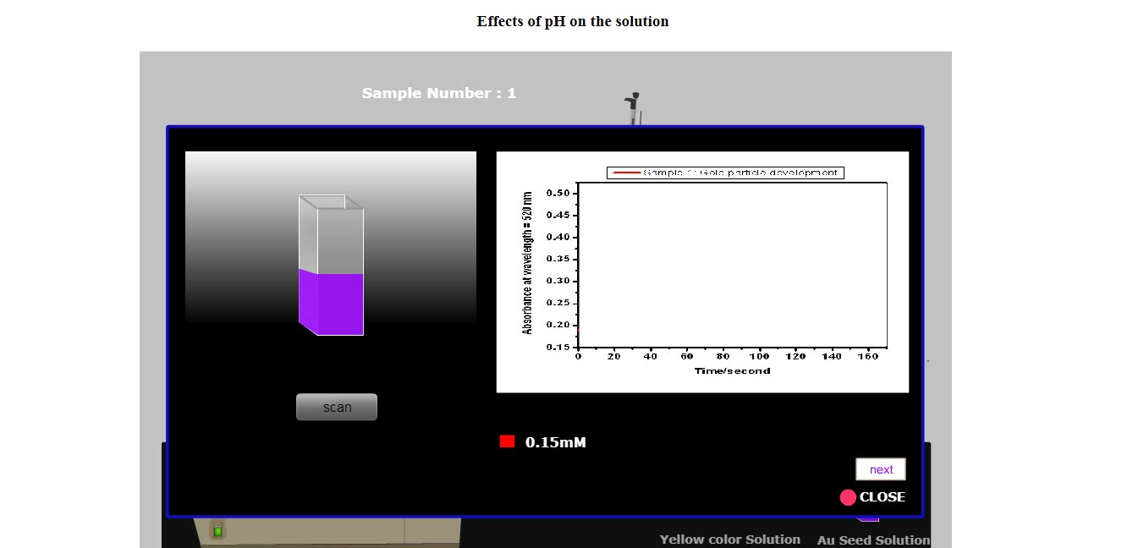

1. After clicking the scan button you need to wait for a little for the graph to complete show up and then you have a choice to click the next button or close button.

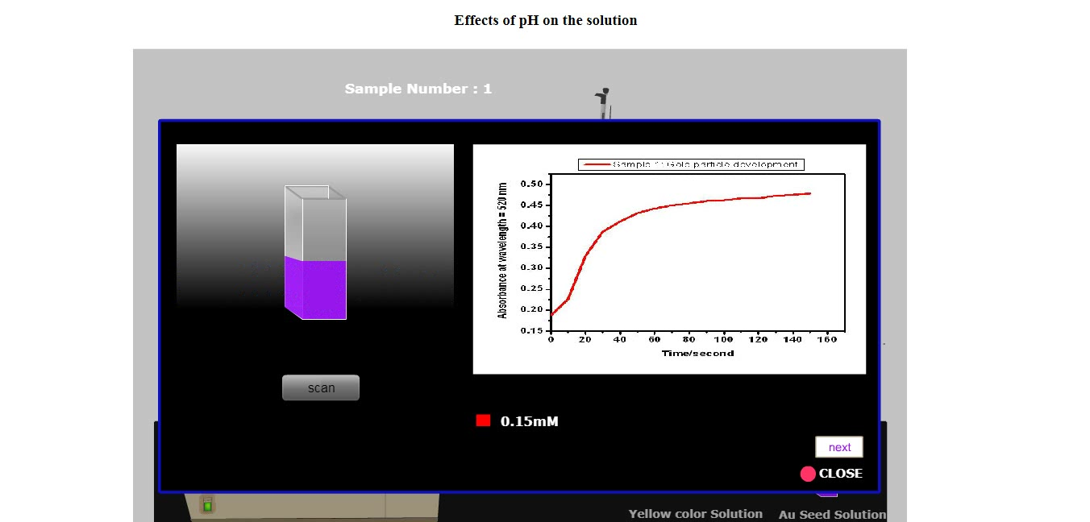

1. On clicking the next button you’ll be able to run the experiment for sample no 2 and after that so on for sample number 3, or if you click the close button you’ll directly redirect to the second part of experiment ie “gold particle catalyzed eosin reduction” .

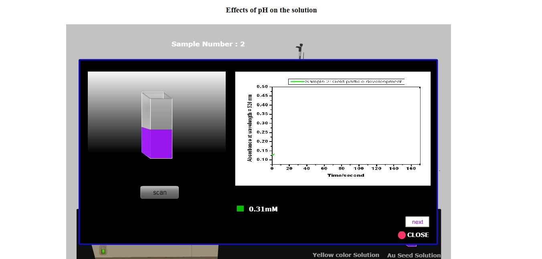

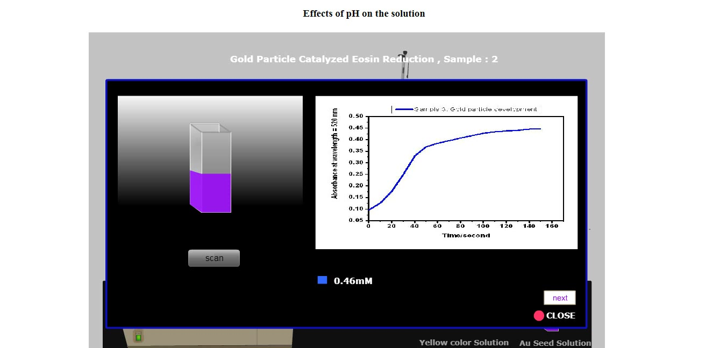

1. Repeat the procedure and follow the pointer to complete the experiment.